**Coding Challenge SQL**

**Virtual Art Gallery Shema DDL and DML**

**STEP 1: TABLE CREATION**

**Create the Artists table**

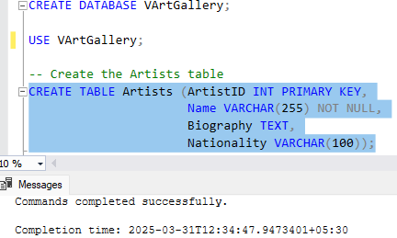

**Create the Categories table**

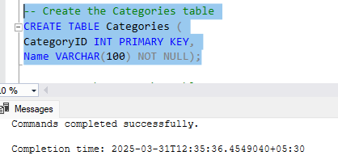

**Create the Artworks table**

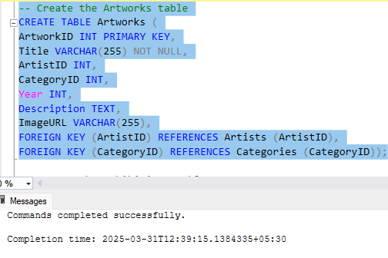

**Create the Exhibitions table**

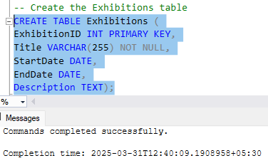

**Create a table to associate artworks with exhibitions**

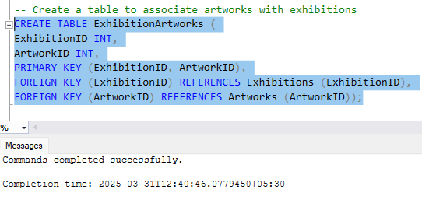

**STEP 2: DATA INSERTION**

**Artists table**

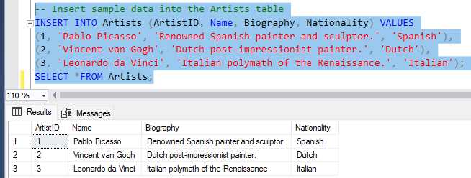

**Categories table**

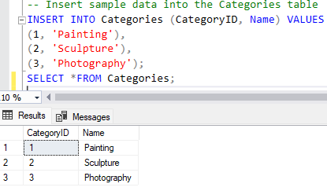

**Artworks table**

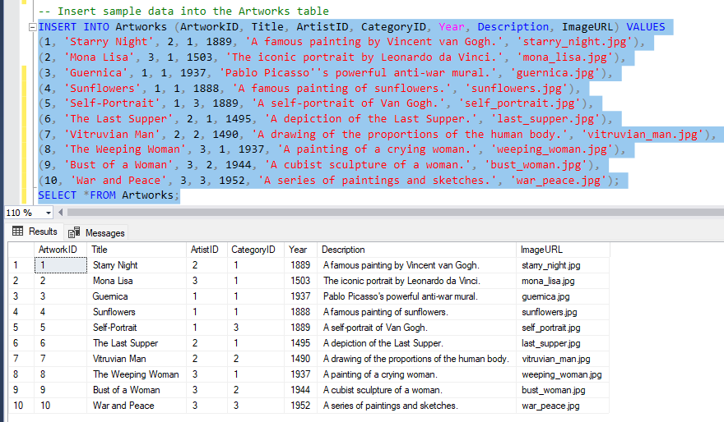

**Exhibitions table**

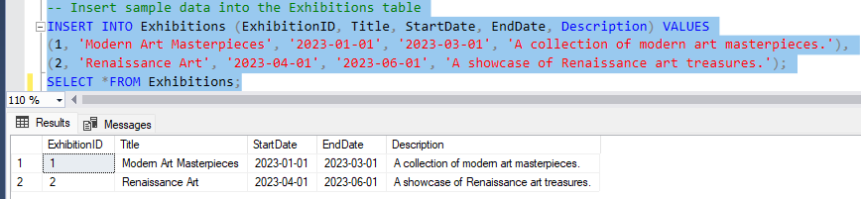

**ExhibitionArtworks table**

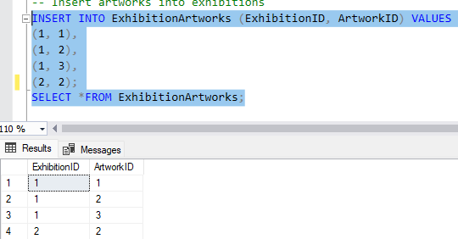

1. **Retrieve the names of all artists along with the number of artworks they have in the gallery, and list them in descending order of the number of artworks.**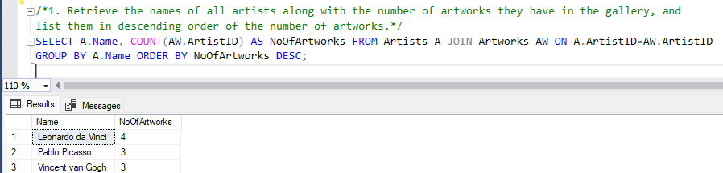
2. **List the titles of artworks created by artists from 'Spanish' and 'Dutch' nationalities, and order them by the year in ascending order.** 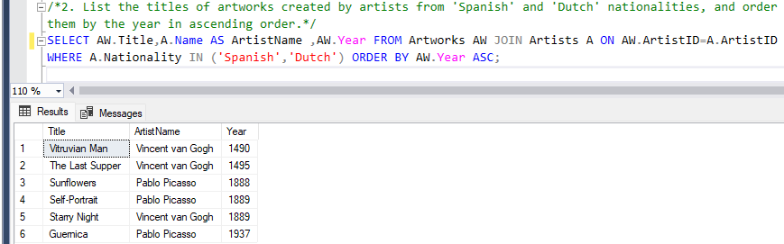
3. **Find the names of all artists who have artworks in the 'Painting' category, and the number of artworks they have in this category.** 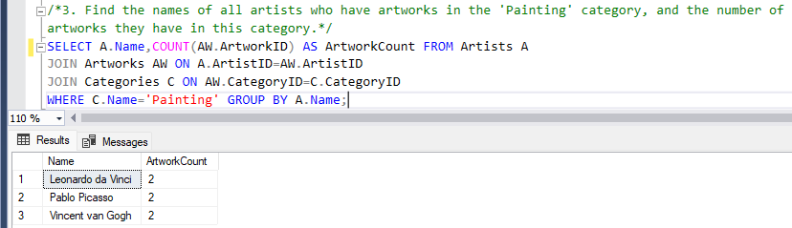
4. **List the names of artworks from the 'Modern Art Masterpieces' exhibition, along with their artists and categories.** 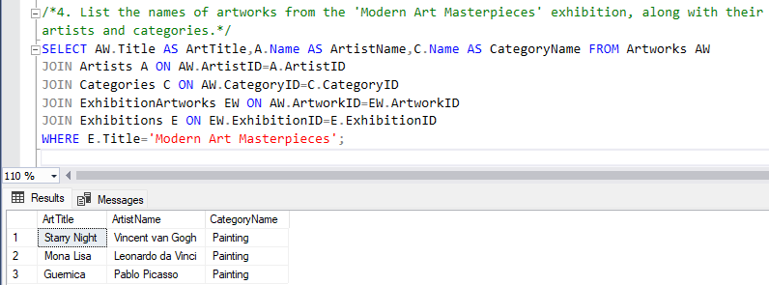
5. **Find the artists who have more than two artworks in the gallery.** 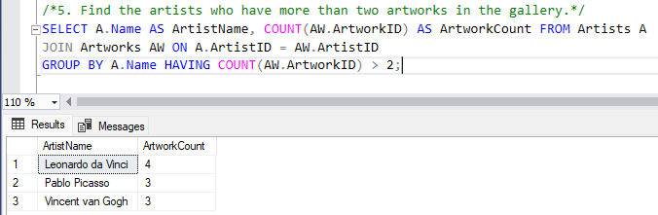
6. **Find the titles of artworks that were exhibited in both 'Modern Art Masterpieces' and 'Renaissance Art' exhibitions**

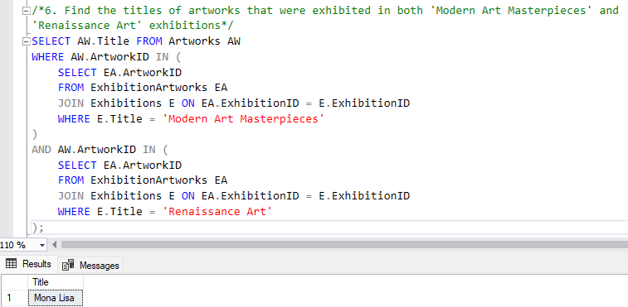

**7. Find the total number of artworks in each category**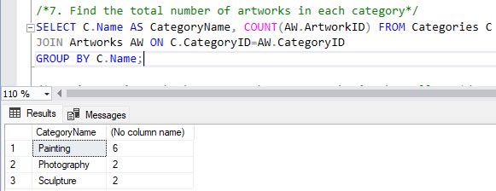

**8. List artists who have more than 3 artworks in the gallery.** 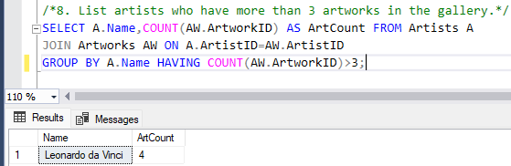

**9. Find the artworks created by artists from a specific nationality (e.g., Spanish).** 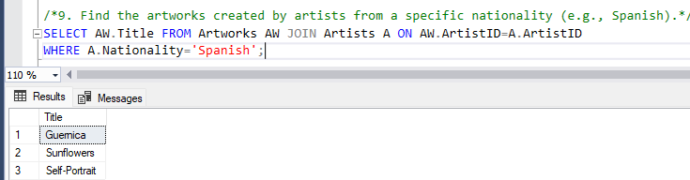

**10. List exhibitions that feature artwork by both Vincent van Gogh and Leonardo da Vinci.** 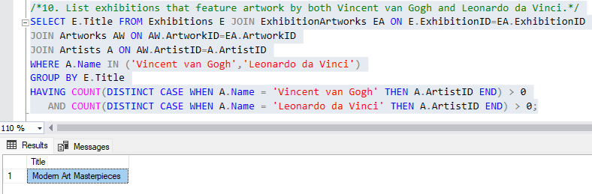

**11. Find all the artworks that have not been included in any exhibition.** 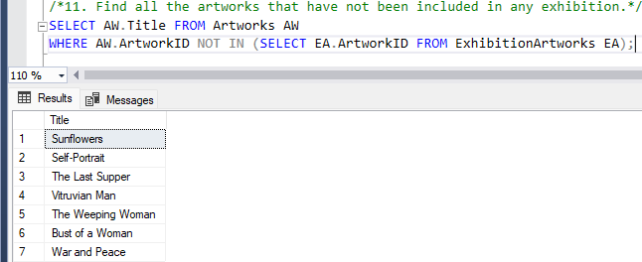

**12. List artists who have created artworks in all available categories.** 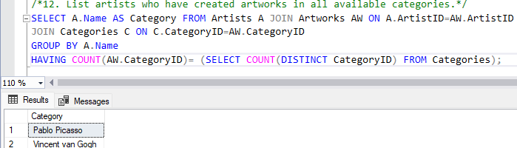

**13. List the total number of artworks in each category.** 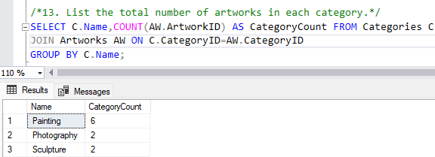

**14. Find the artists who have more than 2 artworks in the gallery.**

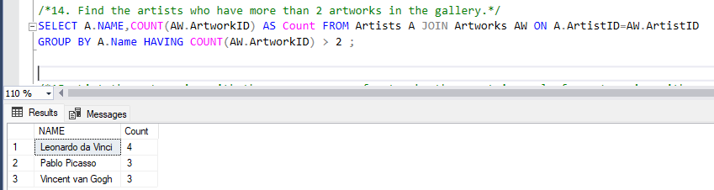

**15. List the categories with the average year of artworks they contain, only for categories with more than 1 artwork.**

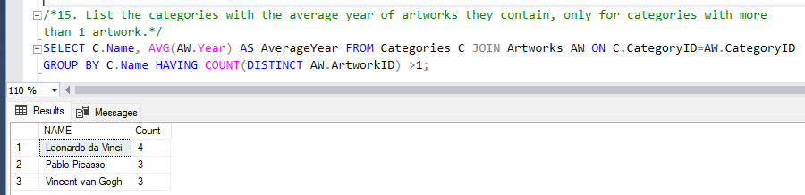

**16. Find the artworks that were exhibited in the 'Modern Art Masterpieces' exhibition.** 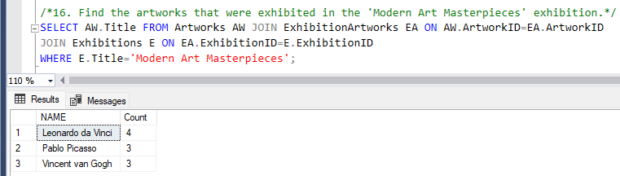

**17. Find the categories where the average year of artworks is greater than the average year of all artworks.**

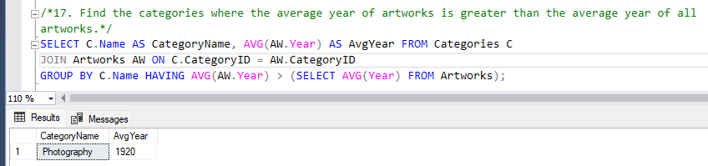

**18. List the artworks that were not exhibited in any exhibition.**

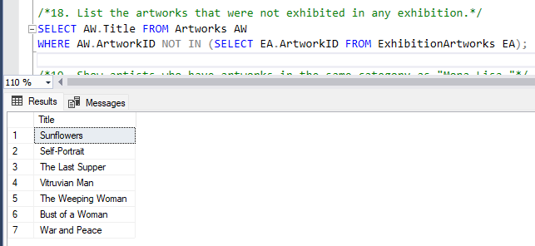

**19. Show artists who have artworks in the same category as "Mona Lisa."**

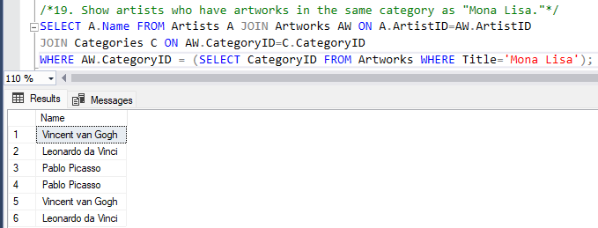

**20. List the names of artists and the number of artworks they have in the gallery.** 